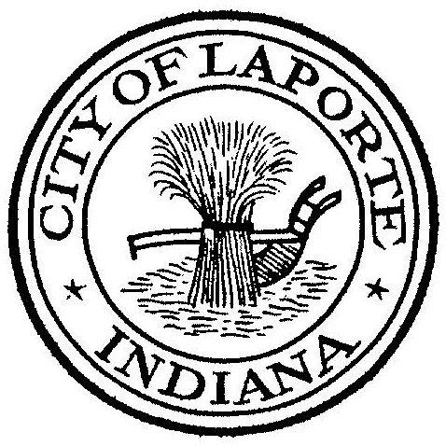
Board of Public Works and Safety
Jessica Romine, Member Tom Dermody, Mayor Mark Kosior, Member
City Hall 801 Michigan Ave., La Porte, IN 46350
Tuesday, April 19, 2022
9:00 AM
AGENDA
- Call To Order
- Pledge Of Allegiance
- Approval Of Minutes
- Public Comment: via Facebook Live
- Clerk-Treasurer: Claims Approval
Temporary Loan Approval
- Department Head Reports
- New Business:
-Sarah Nimetz: Arbor Day Proclamation
-Request For Use: Krazy Kidz Day-Family Advocates/YMCA
-Nick Otis: Collective Bargaining Agreement-Professional Firefighters
-Jerry Jackson: Phosphorus Removal Project Pay Request #1
-Beth West: 5707 Fund Conveyance Agreement
-MaryAnn Richards: Request to Solicit Quotes for Demo: 708 Kingsporte Ln. Using CDBG
Funds
-Jeff Batchelor: Street Sweepings
- Unfinished Business:
- Other Business: Spring Clean Up: Monday, April 25th through Friday, April 29th
10 Adjourn

